Problem 27.2

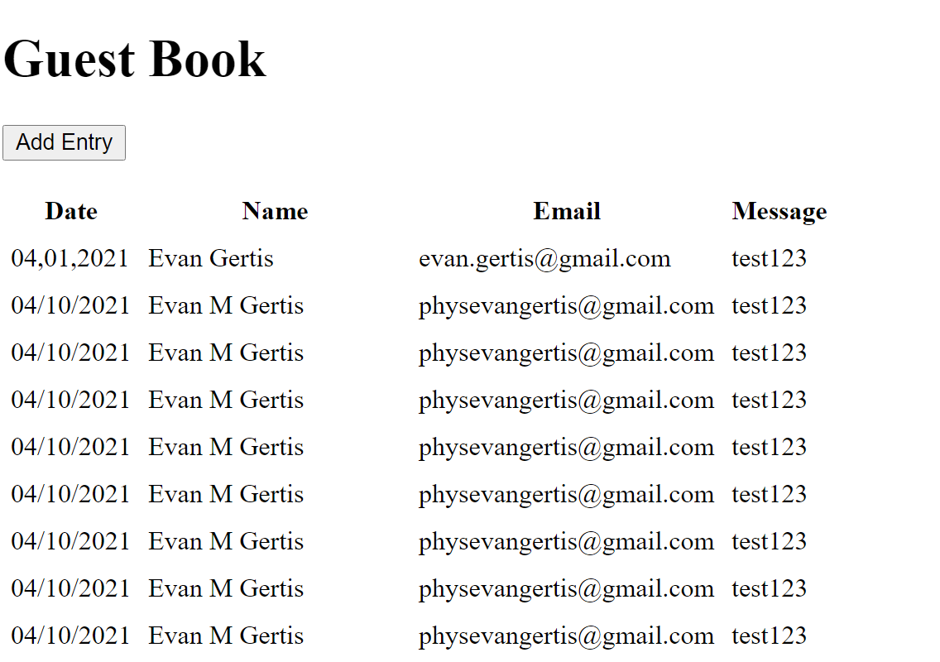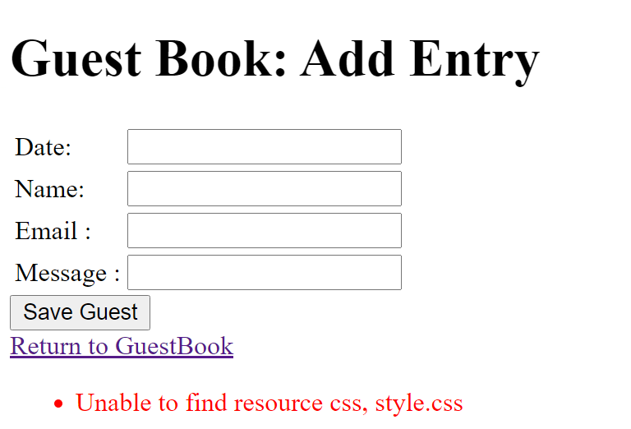

Index.html
<?xml version='1.0' encoding='UTF-8' ?>

<!-- index.html -->
<!-- Displays an h:dataTable of the guests in the guest book -->
<!DOCTYPE html PUBLIC "-//W3C//DTD XHTML 1.0 Transitional//EN"
"http://www.w3.org/TR/xhtml1/DTD/xhtml1-transitional.dtd">
<html xmlns="http://www.w3.org/1999/xhtml"
xmlns:h="http://java.sun.com/jsf/html"
xmlns:f="http://java.sun.com/jsf/core">
<h:head>
<title>Guest Book</title>
<h:outputStylesheet name="style.css" library="css"/>
</h:head>
<h:body>
<h1>Guest Book</h1>
<h:form>
<p><h:commandButton value="Add Entry" action="addentry"/></p>
</h:form>
<h:dataTable value="#{guestbookBean.guests}" var="guest"
rowClasses="oddRows,evenRows" headerClass="header"
styleClass="table" cellpadding="5" cellspacing="0">
<h:column>
<f:facet name="header">Date</f:facet>
#{guest.date}
</h:column>
<h:column>
<f:facet name="header">Name</f:facet>
#{guest.name}
</h:column>
<h:column>
<f:facet name="header">Email</f:facet>
#{guest.email}
</h:column>
<h:column>
<f:facet name="header">Message</f:facet>
#{guest.message}
</h:column>
</h:dataTable>
</h:body>
</html>

addentry.xhtml
<?xml version='1.0' encoding='UTF-8' ?>

<!-- addentry.html -->
<!-- Form for adding an entry to an guest book -->
<!DOCTYPE html PUBLIC "-//W3C//DTD XHTML 1.0 Transitional//EN"
"http://www.w3.org/TR/xhtml1/DTD/xhtml1-transitional.dtd">
<html xmlns="http://www.w3.org/1999/xhtml"
xmlns:h="http://java.sun.com/jsf/html">
<h:head>
<title>Guest Book: Add Entry</title>
<h:outputStylesheet name="style.css" library="css"/>
</h:head>
<h:body>
<h1>Guest Book: Add Entry</h1>
<h:form>
<h:panelGrid columns="3">
<h:outputText value="Date:"/>
<h:inputText id="dateInputText" required="true"
requiredMessage="Please enter the date"
value="#{guestbookBean.date}" maxlength="30"/>
<h:message for="dateInputText" styleClass="error"/>
<h:outputText value="Name:"/>
<h:inputText id="nameInputText" required="true"
requiredMessage="Please enter name"
value="#{guestbookBean.name}" maxlength="30"/>
<h:message for="nameInputText" styleClass="error"/>
<h:outputText value="Email :"/>
<h:inputText id="emailInputText" required="true"
requiredMessage="Please enter your email"
value="#{guestbookBean.email}" maxlength="150"/>
<h:message for="emailInputText" styleClass="error"/>
<h:outputText value="Message :"/>
<h:inputText id="messageInputText" required="true"
requiredMessage="Please enter the message"
value="#{guestbookBean.message}" maxlength="30"/>
</h:panelGrid>
<h:commandButton value="Save Guest"
action="#{guestbookBean.save}"/>
</h:form>
<h:outputLink value="index.xhtml">Return to Guests</h:outputLink>
</h:body>
</html>
GuestBook.java
// GuestBook.java
// Bean for interacting with the GuestBook database
package guestbookbean;

import java.sql.Connection;
import java.sql.PreparedStatement;
import java.sql.ResultSet;
import java.sql.SQLException;
import javax.annotation.Resource;
import javax.faces.bean.ManagedBean;
import javax.sql.DataSource;
import javax.sql.rowset.CachedRowSet;

@ManagedBean(name
= "guestbookBean")
public class GuestBook {
// instance variables that represent one guest

private String date;
private String name;
private String email;
private String message;

// allow the server to inject the DataSource
@Resource(name
= "jdbc/sample")
DataSource dataSource;

public String getDate(){
return this.date;
}

public void setDate(String date){
this.date = date;
}

public String getEmail() {
return this.email;
}

public void setEmail(String email){
this.email = email;
}

public String getName(){
return this.name;
}

public void setName(String name){
this.name = name;
}

public String getMessage(){
return this.message;
}

public void setMessage(String message){
this.message = message;
}

// return a ResultSet of entries
public ResultSet getGuests()
throws SQLException {
// check whether dataSource was injected by the server
if (dataSource
== null) {
throw new SQLException("Unable to obtain DataSource");
}

// obtain a connection from the connection pool
Connection connection
= dataSource.getConnection();

// check whether connection was successful
if (connection
== null) {
throw new SQLException("Unable to connect to DataSource");
}

try {
// create a PreparedStatement to insert a new guest book entry
PreparedStatement getGuests
= connection.prepareStatement(
"SELECT DATE, NAME, EMAIL, MESSAGE FROM GUESTBOOK");

CachedRowSet rowSet
= new com.sun.rowset.CachedRowSetImpl();
rowSet.populate(getGuests.executeQuery());
return rowSet;
} // end try
finally {
connection.close(); // return this connection to pool
} // end finally
} // end method getGuests

// save a new guest book entry
public String save()
throws SQLException {
// check whether dataSource was injected by the server
if (dataSource
== null) {
throw new SQLException("Unable to obtain DataSource");
}

// obtain a connection from the connection pool
Connection connection
= dataSource.getConnection();

// check whether connection was successful
if (connection
== null) {
throw new SQLException("Unable to connect to DataSource");
}

try {
// create a PreparedStatement to insert a new guest book entry
PreparedStatement addEntry
= connection.prepareStatement("INSERT INTO GUESTBOOK "
+ "(DATE,NAME,EMAIL,MESSAGE)"
+ "VALUES ( ?, ?, ?, ?)");

// specify the PreparedStatement's arguments
addEntry.setString(1,
getDate());
addEntry.setString(2,
getName());
addEntry.setString(3,
getEmail());
addEntry.setString(4,
getMessage());

addEntry.executeUpdate(); // insert the entry
return "index"; // go back to index.xhtml page
} // end try
finally {
connection.close(); // return this connection to pool
} // end finally
} // end method save
} // end class GuestBook

Problem 27.3
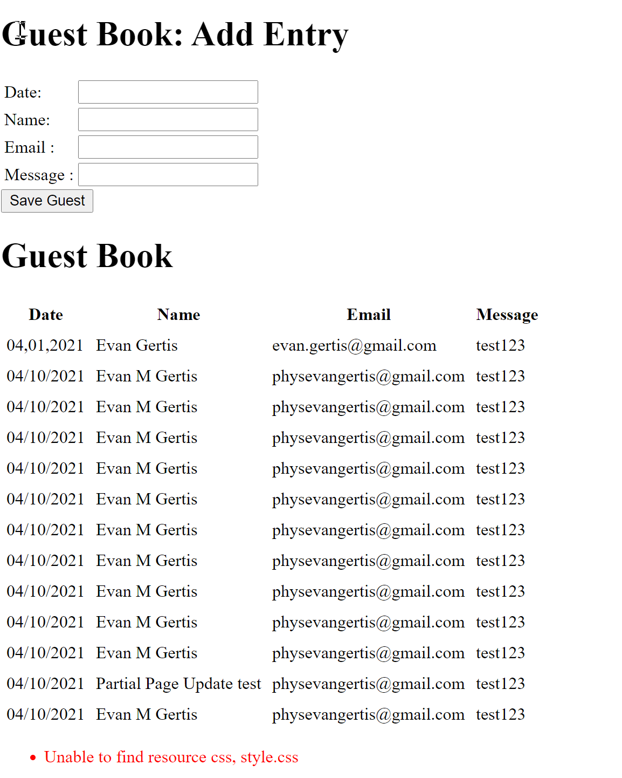
Index.xhtml
<?xml version='1.0' encoding='UTF-8' ?>

<!-- index.html -->
<!-- Displays an h:dataTable of the guests in the guest book -->
<!DOCTYPE html PUBLIC "-//W3C//DTD XHTML 1.0 Transitional//EN"
"http://www.w3.org/TR/xhtml1/DTD/xhtml1-transitional.dtd">
<html xmlns="http://www.w3.org/1999/xhtml"
xmlns:h="http://java.sun.com/jsf/html"
xmlns:f="http://java.sun.com/jsf/core">
<h:head>
<title>Guest Book</title>
<h:outputStylesheet name="style.css" library="css"/>
</h:head>
<h:body>
<h1>Guest Book: Add Entry</h1>
<h:form>
<h:panelGrid columns="3">
<h:outputText value="Date:"/>
<h:inputText id="dateInputText" required="true"
requiredMessage="Please enter the date"
value="#{guestbookBean.date}" maxlength="30"/>
<h:message for="dateInputText" styleClass="error"/>
<h:outputText value="Name:"/>
<h:inputText id="nameInputText" required="true"
requiredMessage="Please enter name"
value="#{guestbookBean.name}" maxlength="30"/>
<h:message for="nameInputText" styleClass="error"/>
<h:outputText value="Email :"/>
<h:inputText id="emailInputText" required="true"
requiredMessage="Please enter your email"
value="#{guestbookBean.email}" maxlength="150"/>
<h:message for="emailInputText" styleClass="error"/>
<h:outputText value="Message :"/>
<h:inputText id="messageInputText" required="true"
requiredMessage="Please enter the message"
value="#{guestbookBean.message}" maxlength="30"/>
</h:panelGrid>
<h:commandButton value="Save Guest"
action="#{guestbookBean.save}">
<f:ajax execute="dateInputText nameInputText emailInputText messageInputText" render="dataTable"/>
</h:commandButton>
</h:form>
<h1>Guest Book</h1>
<h:dataTable id="dataTable" value="#{guestbookBean.guests}" var="guest"
rowClasses="oddRows,evenRows" headerClass="header"
styleClass="table" cellpadding="5" cellspacing="0">
<h:column>
<f:facet name="header">Date</f:facet>
#{guest.date}
</h:column>
<h:column>
<f:facet name="header">Name</f:facet>
#{guest.name}
</h:column>
<h:column>
<f:facet name="header">Email</f:facet>
#{guest.email}
</h:column>
<h:column>
<f:facet name="header">Message</f:facet>
#{guest.message}
</h:column>
</h:dataTable>
</h:body>
</html>

GuestBook.java
// GuestBook.java
// Bean for interacting with the GuestBook database
package guestbookbean;

import java.sql.Connection;
import java.sql.PreparedStatement;
import java.sql.ResultSet;
import java.sql.SQLException;
import javax.annotation.Resource;
import javax.faces.bean.ManagedBean;
import javax.sql.DataSource;
import javax.sql.rowset.CachedRowSet;

@ManagedBean(name
= "guestbookBean")
public class GuestBook {
// instance variables that represent one guest

private String date;
private String name;
private String email;
private String message;

// allow the server to inject the DataSource
@Resource(name
= "jdbc/sample")
DataSource dataSource;

public String getDate(){
return this.date;
}

public void setDate(String date){
this.date = date;
}

public String getEmail() {
return this.email;
}

public void setEmail(String email){
this.email = email;
}

public String getName(){
return this.name;
}

public void setName(String name){
this.name = name;
}

public String getMessage(){
return this.message;
}

public void setMessage(String message){
this.message = message;
}

// return a ResultSet of entries
public ResultSet getGuests()
throws SQLException {
// check whether dataSource was injected by the server
if (dataSource
== null) {
throw new SQLException("Unable to obtain DataSource");
}

// obtain a connection from the connection pool
Connection connection
= dataSource.getConnection();

// check whether connection was successful
if (connection
== null) {
throw new SQLException("Unable to connect to DataSource");
}

try {
// create a PreparedStatement to insert a new guest book entry
PreparedStatement getGuests
= connection.prepareStatement(
"SELECT DATE, NAME, EMAIL, MESSAGE FROM GUESTBOOK");

CachedRowSet rowSet
= new com.sun.rowset.CachedRowSetImpl();
rowSet.populate(getGuests.executeQuery());
return rowSet;
} // end try
finally {
connection.close(); // return this connection to pool
} // end finally
} // end method getGuests

// save a new guest book entry
public String save()
throws SQLException {
// check whether dataSource was injected by the server
if (dataSource
== null) {
throw new SQLException("Unable to obtain DataSource");
}

// obtain a connection from the connection pool
Connection connection
= dataSource.getConnection();

// check whether connection was successful
if (connection
== null) {
throw new SQLException("Unable to connect to DataSource");
}

try {
// create a PreparedStatement to insert a new guest book entry
PreparedStatement addEntry
= connection.prepareStatement("INSERT INTO GUESTBOOK "
+ "(DATE,NAME,EMAIL,MESSAGE)"
+ "VALUES ( ?, ?, ?, ?)");

// specify the PreparedStatement's arguments
addEntry.setString(1,
getDate());
addEntry.setString(2,
getName());
addEntry.setString(3,
getEmail());
addEntry.setString(4,
getMessage());

addEntry.executeUpdate(); // insert the entry
return "index"; // go back to index.xhtml page
} // end try
finally {
connection.close(); // return this connection to pool
} // end finally
} // end method save
} // end class GuestBook

